PROJECT 2

EXPLORATORY DATA ANALYTICS (EDA) REPORT

1. Summary
The analysed dataset contains transactional records for an e-commerce or retail business, tracking a total of 1200 unique orders across 14 distinct attributes. The primary financial metrics show a robust distribution of transaction values, with a strong positive relationship between the quantity of items purchased and the total price. A small segment of high-value transactions (8 orders) has been flagged as statistical outliers, representing premium or bulk-purchase behaviours.
2. Dataset Overview & Structure
Dimensions: The dataset consists of a matrix of 1200 rows and 14 columns.
Key Tracking Variables:
Identifiers: OrderID, CustomerID
Temporal: Date (spanning multiple years, e.g., 2023–2025)
Marketing Indicators: CouponCode (e.g., SAVE10, FREESHIP, WINTER15) and ReferralSource (e.g., Instagram, Facebook, Email, Google, Referral)
Target Metric: TotalPrice
3. Univariate Analysis: Total Price
A descriptive statistical overview of the TotalPrice metric provides the following summary:
Metric Value
Total Record Count :1200
Mean Order Value: $1053.97
Median Order Value: $823.62
Minimum Value: $11.39
Maximum Value: $3456.40
Key Distribution Insight:
The mean $1053.97 is substantially higher than the median $823.62. This indicates that the distribution of order prices is right-skewed (positively skewed). The majority of purchases are concentrated below $1000, but the overall average is pulled upward by a subset of high-value transactions.
4. Outlier Analysis
A total of 8 outliers were identified on the upper tail of the distribution. These entries consist of exceptionally large orders with purchase amounts exceeding $3300:
Outlier Volume: 8 out of 1200 transactions (representing approximately 0.67% of the dataset).
Price Range: Values extend from a low of $3334.00 up to the absolute maximum of $3456.40.
Channel Affiliation:
Facebook and Email appear frequently as the traffic sources for these outliers.
Multiple high-value transactions (such as ORD200469 at $3384.90 and ORD201122 at $3390.95) did not utilize any promotional discount codes (CouponCode is None), pointing to organic, high-intent premium or wholesale shoppers.
5. Trend Analysis: Quantity vs. Total Price
Analyzing how the TotalPrice behaves relative to the number of units ordered reveals a predictable, linear scaling effect:
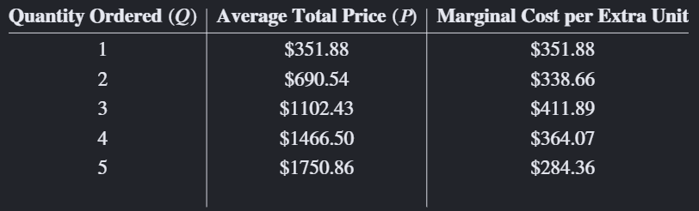
Key Trend Insight:
Each additional unit increases the average order value by roughly $340 to $400. This highly consistent growth indicates stable item pricing across orders and suggests that basket volume is a primary driver of top-line revenue growth.
6. Strategic Recommendations
Optimize High-Value Channels: Because Facebook and Email are linked to top-tier organic outlier purchases, VIP customer flows or retargeting strategies should be heavily concentrated on these platforms.
Encourage Higher Basket Size: Given that average price steps up linearly with quantity, introducing tiered promotions (e.g., "Spend $1000 or buy 3+ items to receive free shipping/extra discounts") could effectively push mid-tier customers into higher spending brackets.
Review Low-Margin Thresholds: The minimum order value drops down to $11.39. Management should ensure that appropriate minimum spending thresholds or shipping fees are in place so that low-value orders remain profitable after fulfilment costs

